Name: ___Diana____________________
Student ID: ___________________
Date: ___________________

Instructions: Congratulations, you made it to the end of the course! Use the following to have a written discussion about your experience in the course and the final project. After you answer the questions below, insert a screenshot of each of the pages you have completed so far (remember, you should have at least 4 and the CSS file). Do NOT screenshot the html code because we can’t run the code. Save the file to yourasurite – Project – Assignment 5.docx file and yourasurite – Project – Assignment 5.pdf file.

Before submitting this document and all your project files, make sure you meet all of these requirements listed in the CIS300 Project Instructions.pdf file.

Discussion Questions
- Now that you are finished with your project, your original concept of your project might have changed a lot. Discuss in detail the differences between your initial project design and your final product. Why did you make these changes (if you had any)? (5 points)
Between the original concept and the final product, I would say the changes most apply to the design and layout of the website. I made these changes to add a sense of balance and cohesiveness with meeting the requirements of the assignment. I also wanted all the focus to be on my projects, so it was essential to create an engaging layout without detracting from the actual subjects.
- Describe in detail why you chose the design layout you did. Are you happy with the outcome? Did you run into any issues with your design while developing your site? What did you do to overcome those issues? Would you do anything differently the next time you designed a website? (5 points)
Overall, I am content with the design of my website. I wanted a simplistic look to maintain the color and detail on my projects rather than on my website. The issues I faced were trying to maintain the simplistic look, but creating pages that were different and creative. I referenced a lot of portfolios and experimented with a lot of different layouts to come to a resolution. I am happy with what I concluded, but I could’ve used more experimental designs and images to create a more interesting layout and movement throughout my pages, filling the areas where there is negative space.
- You likely encountered challenges while working on your final project. In detail, describe the challenges you encountered and what you did to overcome them. (5 points)
One of the challenges that stumped me was creating a photo gallery to display my work. My vision was to create a staggered gallery like how Pinterest displays its posts. I kept going back and forth, adjusting my styles to create a grid to create said look, but it never organized the way I wanted. I concluded that I needed to do some research and look at tutorials to help me achieve this look. The result was, I approached it the wrong way because using a grid was unnecessary, and with the help of a tutorial, I achieved my staggered Pinterest-like gallery.
- Describe several concepts that you learned during this course that you found interesting and useful. Where there any concepts that you wish more time was spent on? Is there anything you would have like to incorporate into your final project that wasn’t covered during this course? (5 points)
Grids and Flexbox were the concepts I had the most difficulty understanding, so I wish I had spent more time studying and using them to help me gain a deeper perspective on them. Something that I would like to incorporate into my final project would be transitions as you move through the pages. I think it would add a lot of attention to my pieces while maintaining simplicity.

- List your project website's GitHub URL. (3 points)
https://dianatle527.github.io/portfolio.github.io/

- Insert your website’s Google Analytics Realtime Overview Screenshot below (10 points)
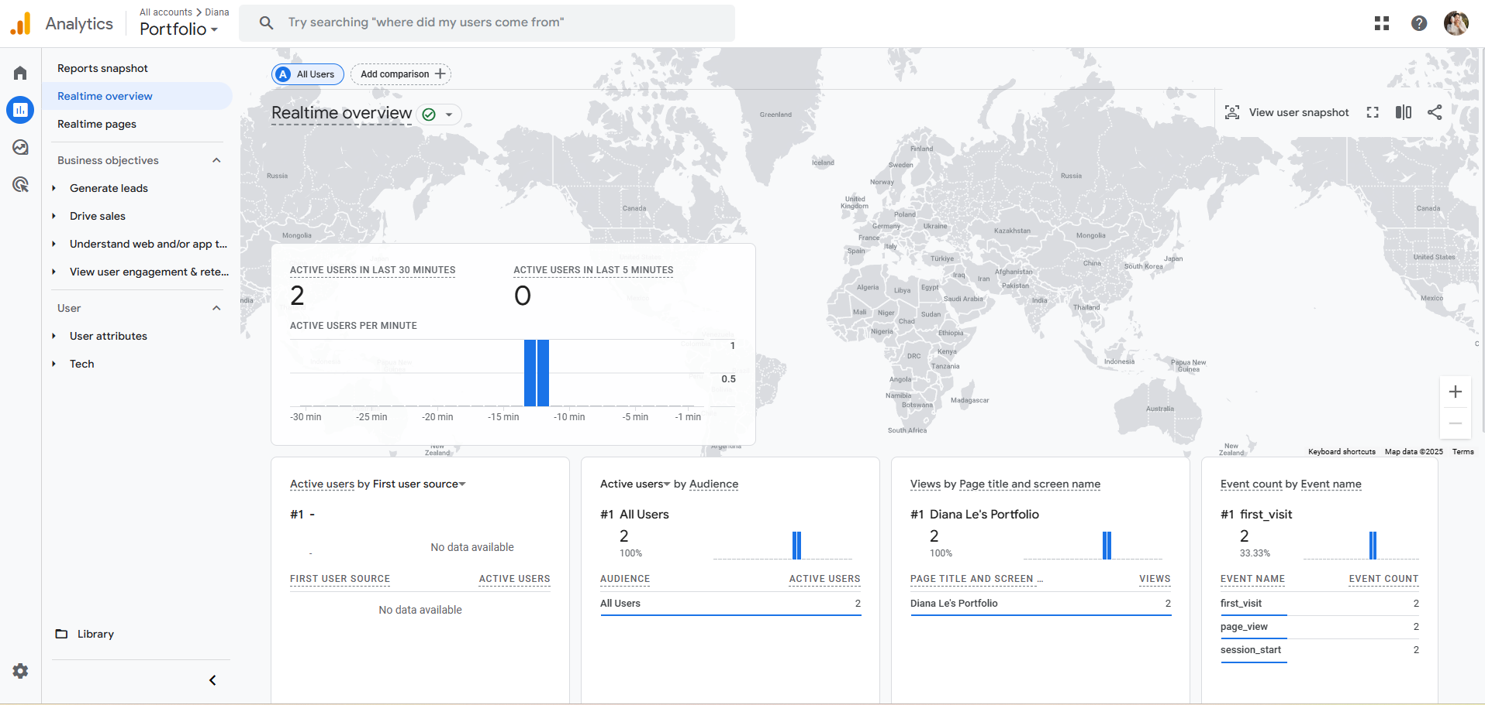

- While trying to be as objective and unbiased as possible, please go through and critique your own site using the attached rubric. In the student critique column, indicate which score you should receive for each category (outstanding, average, or needs improvement) and write a short (1 or two sentence max) justification of that score. (5 points)
Student Critique
 | Outstanding | Average | Needs Improvement | Student Critique
EXAMPLE | You did everything! | You did a few things. | You did nothing… | Outstanding – I believe I did everything correctly because of x, y, and z.
Visual Appeal | Use of color, contrast, text, graphics is appealing to target audience | Appealing to target audience in all but one area. | Not appealing to target audience in more than one area | Simple, clear, and direct, but lacks a wow factor.
Navigation | Easy to use, consistent | Inconsistent or difficult to use | Missing | Everything is labeled and indicates clearly what and where.
Page Titles/ Logo Area | Descriptive and include the site/company name | -- | Missing or does not include the site/company name | Titles and headers are in big, clear, and interesting fonts.
Table | Present and correct syntax | -- | Missing or incorrect syntax | Clean the table properly, organizing the information cited.
Video | Present and correct syntax | -- | Missing or incorrect syntax | Present and relevant to the topic.
E-mail Link | Present and correct syntax | -- | Missing or incorrect syntax | Present and easily found.
Outside Link | Present and correct syntax | -- | Missing or incorrect syntax | Present and easily found.
Meta tag | Correct syntax (description meta tags), excellent selection of keywords and meaningful description | Correct syntax (description meta tags), adequate selection of keywords and description | Missing or incorrect syntax | Present, clear, and direct.
Form Coding | Contains 4 or more form fields, correct syntax, and meaningful form element names | Does not contain the required 4 form fields, incorrect syntax, or names of fields don’t make sense. | Missing | Organized properly and used correctly.
Form Processing | Form uses # as the action. | -- | Form not configured correctly. | Form is correctly configured.

Web page browser view screenshot of Home Page
This page includes ____ video, ____ form, ____ table, ____ email, or ____ external links.
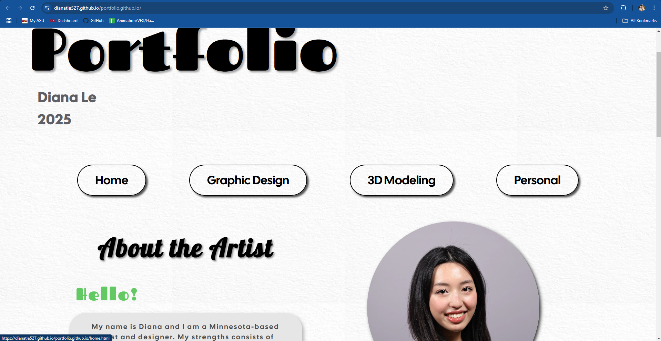
Web page browser view screenshot of Page #1
This page includes ____ video, ____ form, ____ table, ____ email, or ____ external links.
Web page browser view screenshot of Page #2
This page includes ____ video, ____ form, ____ table, ____ email, or ____ external links.
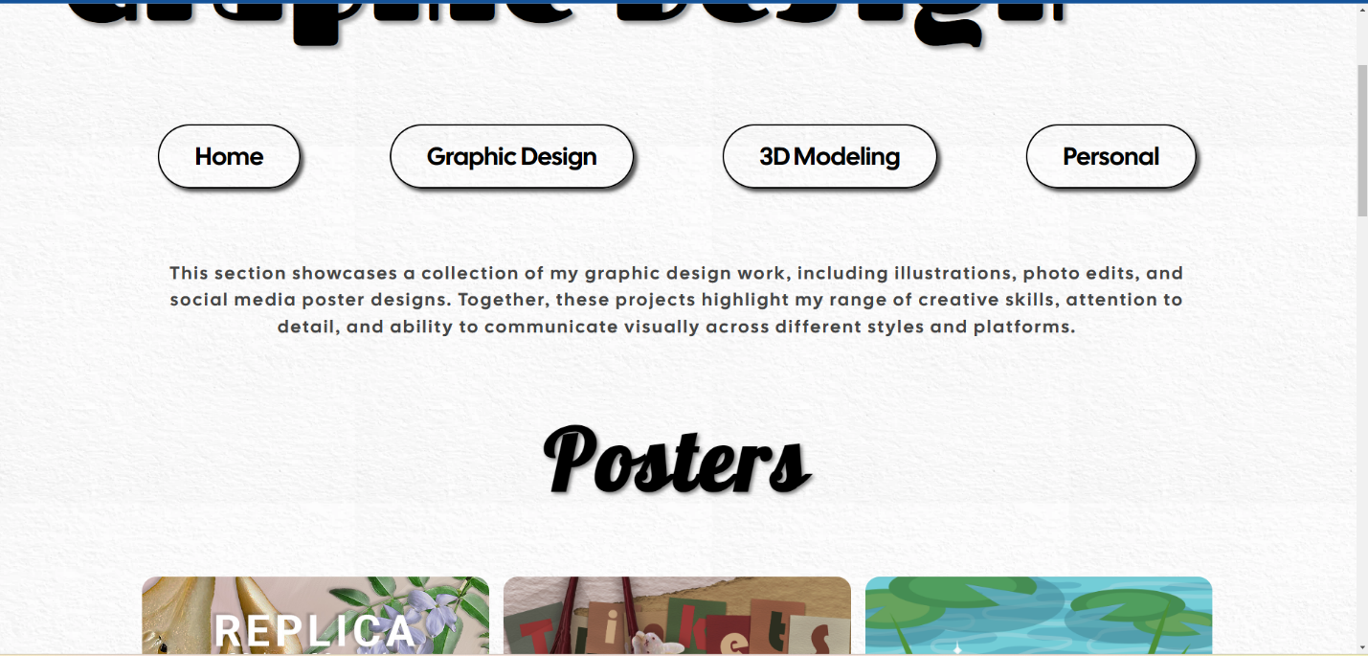
Web page browser view screenshot of Page #3
This page includes ____ video, ____ form, ____ table, ____ email, or ____ external links.
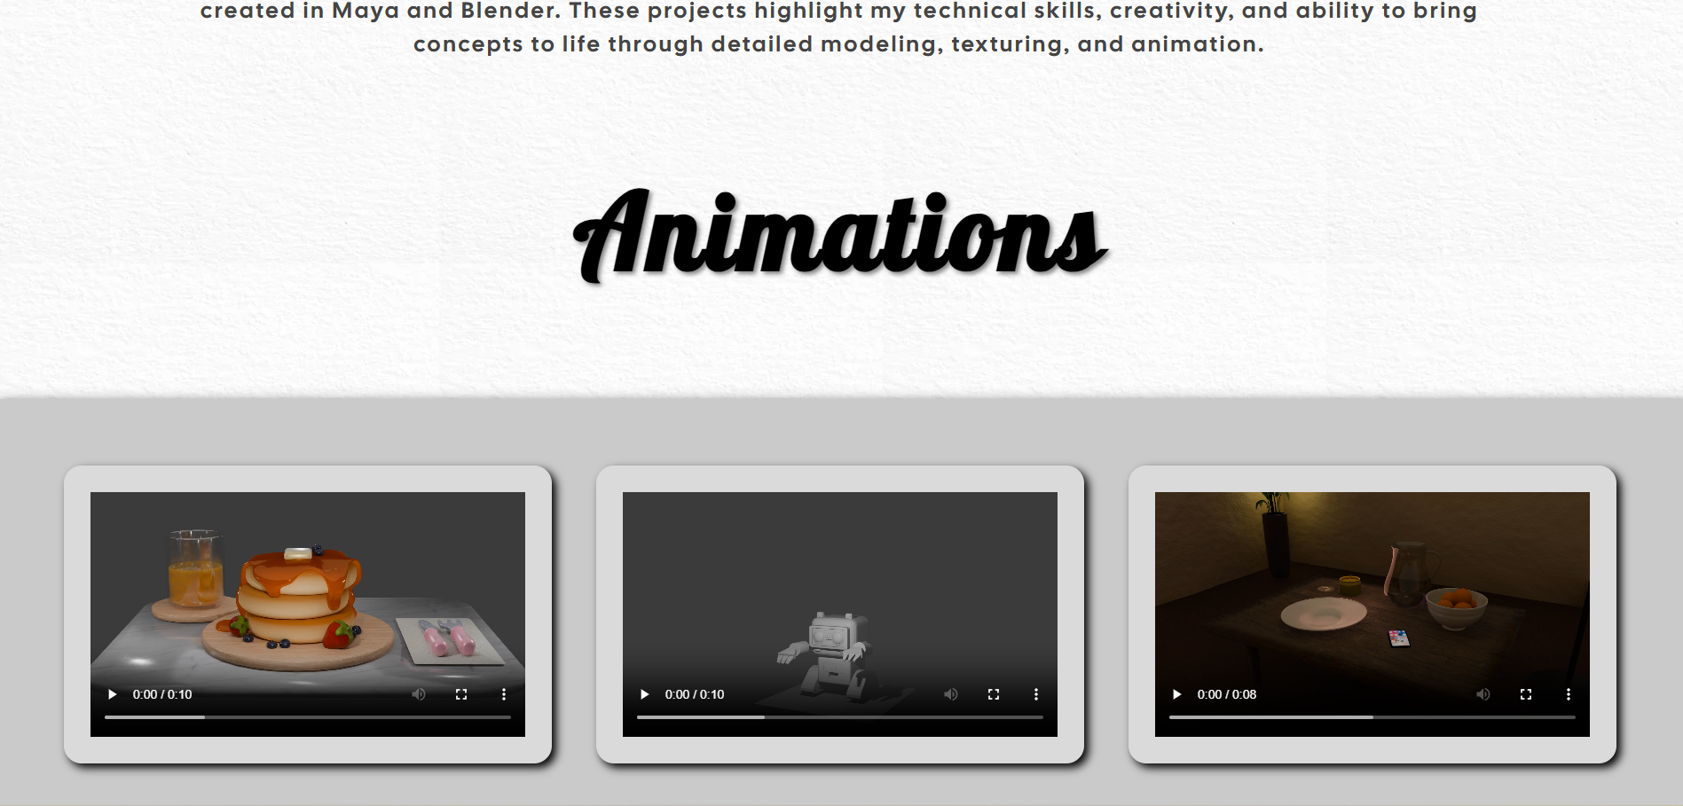
Web page browser view screenshot of Page #4 (if it available)
This page includes ____ video, ____ form, ____ table, ____ email, or ____ external links.
